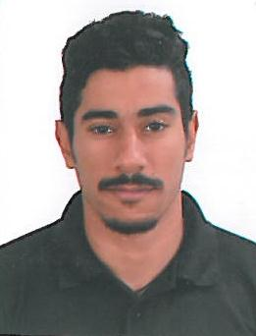

**Curriculum Vitae**

## Hussain Mahmood Hussain Abdulla Manoojahri

**ADDRESS**

Villa 2002, Road 3458,

block 734, Bahrain

Mob.: +973 36696952

Email: hosyno.17@gmail.com

**PERSONAL PROFILE**

**I am self motivated individual and i posses great**

**Determination and enthusiasm to sucsed and excel in my**

**Chosen career path. I am flexible and am able to performe**

**Any given task creatively and with efficiency. I am both flexible**

**And gymnastic, I realize challenges with the aim to broaden**

**My technical and practical know how in order to acquine**

**And advance my skills.**

**PERSONAL DETAILS**

Birthday: 30 January 1993

Age: 23 years old

Nationality: Bahraini

Status: Married

Language Spoken: English, Arabic

**SKILLS**

* Microsoft Office (Word, Excel, Power Point, Outlook)
* Internet explorer

**WORK EXPERIENCE**

* Aluminum of Bahrain (ALBA) :

13 Jan 2009 Trainee as a School Student in Department (Techician Electrical)

▪️ Arman Hotel (Security) 2017 As Part Time

* Mohamed barwane petroleum service (mbps):

March 2011 to Feb 2013 acting floor man

* Bahrain Cinema CINECO

Jan 2015 to Nov 2016 Cinema guide

River Island (Alshaya Group)

Feb 2017 to Jan 2018 Sales Man & Machindiser & stack room

ALGHALIAW.L.L.

Feb 2018 till now Account & Admin Supervisor (FARM)

**EDUCATION AND PROFESSIONAL CERTIFICATION**

* **City & Guilds level 1 & 2 English Certificate**

ESOL international

27 May 2009

* **Telecommunication/Techician Electronics Engineering**

Al Jabirya Secondary School

June 2010

* **Mohamed barwane petroleum service (mbps)**

Safety certificate

March 2012

* **British council (BC)**

English courses

**REFERENCE**

Available upon request